Decorators

Decorators are special functions in python.
Decorators are used to extend functionality of existing function without modifying or without updating.
Decorators are developed using nested functions.

Advantage of decorators
- Function transforming (OR) Transforming one function to another function
- Extending functionality of existing function without modifying existing function (OR) Adding some extra code to existing function without modifying existing code.

Decorators are 2 types
- Predefined decorators
- User defined decorators

The decorators provided by python are called predefined decorators.
Example: @staticmethod,@classmethod,@property,@abstractmethod

The decorators build by programmer are called user defined decorators.

Basic steps for developing decorators
- Developing Decorator
- Applying Decorator

Develop Decorator or Create Decorator
Decorator is developed using nested functions.

Basic steps for developing decorator
- Define function with single parameter. This parameter receives function as input.
- Inside function, define another function (wrapper function/inner function). This wrapper function add new functionality to the existing function/the function which is received by outer function/decorator function
- Outer function returns wrapper function/inner function.

Applying decorator
Decorator is applied to function using @decorator-name syntax.

Syntax:
@decorator-name
def function-name([parameters]):
statement-1
statement-2

Example:
def box(function):
def wrapper_function():
print("*"*40)
function()
print("*"*40)
return wrapper_function

@box
def fun1():
print("PYTHON")
@box
def fun2():
print("JAVA LANGUAGE")

fun1()
fun2()

Output
****************************************
PYTHON
****************************************
****************************************
JAVA LANGUAGE
****************************************

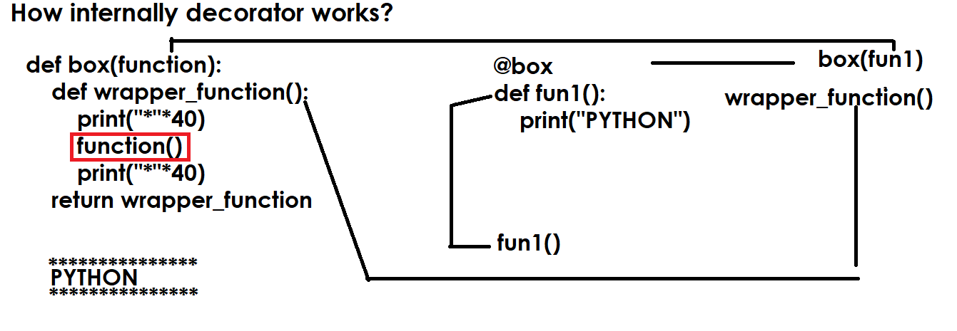

Example:
#decorator function
def box(function):
def wrapper_function():
print("*"*40)
function()
print("*"*40)
return wrapper_function

def fun1():
print("PYTHON")

@box
def fun2():
print("JAVA")

#Internal
f=box(fun1)
f()

fun2()
Output
****************************************
PYTHON
****************************************
****************************************
JAVA
****************************************

Applications of decorators
- Authentication decorator
- Authorization decorator
- Code debugging decorator
- Code Testing decorator
- Logging decorators/Loggers

Example:
import random
#Decorator
def otp_authentication(function):
def wrapper():
otp=random.randint(1000,9999)
print(f'Input OTP {otp} for authentication')
iotp=int(input("OTP :"))
if otp==iotp:
function()
else:
print("Invalid OTP No")
return wrapper

@otp_authentication
def deposit():
print("deposit function")

@otp_authentication
def withdraw():
print("withdraw function")
@otp_authentication
def login():
print("welcome")

Output
Input OTP 9800 for authentication
OTP :9800
deposit function
Input OTP 3270 for authentication
OTP :3270
withdraw function
Input OTP 5241 for authentication
OTP :5241
Welcome

Example:
def smart_division(function):
def wrapper(n1,n2):
if n2==0:
return 0
else:
return function(n1,n2)
return wrapper

@smart_division
def division(n1,n2):
n3=n1/n2
return n3

res=division(5,2)
print(res)
res=division(6,0)
print(res)

Output
2.5
0

decorator with parameters

decorator is having one required parameter called function.
A part of this it can receive other values. in order to receive, it required parameters

Syntax:
def outer-function(param,param,param,..):
def decorator-name(function):
def wrapper([parameters]):
statement-1
function()
statement-2
return wrapper
return decorator-name

Example:
def authentication(user,pwd):# Which receives values/outer layer
def authenticate(function): # actual decorator
def wrapper():
if user=='nit' and pwd=='n123':
function()
else:
print("invalid username or password")
return wrapper
return authenticate

@authentication(user='nit',pwd='n123')
def login():
print("welcome")

login()

Output
welcome

invalid username or password

Example:
def sort(order):
def sorting(function):
def wrapper(a):
if order=="ascending":
for i in range(len(a)):
for j in range(len(a)-1):
if a[j]>a[j+1]:
a[j],a[j+1]=a[j+1],a[j]
else:
for i in range(len(a)):
for j in range(len(a)-1):
if a[j]<a[j+1]:
a[j],a[j+1]=a[j+1],a[j]
function(a)
return wrapper
return sorting

@sort('descending')
def display_list(a):
print(f'List is {a}')

list1=[6,9,2,5,7,1,4,2,4]
display_list(list1)

Output
List is [9, 7, 6, 5, 4, 4, 2, 2, 1]

